A monitoring system must inspect a list from beginning to end and also update selected elements during traversal. Choose between Iterator, ListIterator and index-based traversal, and justify the choice. [Iterators]

Aim
To develop a Java program that traverses a list from beginning to end and updates selected elements during traversal using a ListIterator.

Why ListIterator?
- Iterator
  - Can traverse only in the forward direction.
  - Can remove elements.
  - Cannot update elements directly.
- ListIterator (Best Choice)
  - Traverses forward and backward.
  - Can update (set()), add (add()), and remove (remove()) elements while traversing.
  - Ideal when elements need to be modified during iteration.
- Index-Based Traversal
  - Uses get(index) and set(index, value).
  - Suitable for simple updates.
  - Less efficient for linked lists and does not provide safe modification during iteration.
Justification:
Since the monitoring system needs to inspect the list from beginning to end and update selected elements during traversal, ListIterator is the most appropriate choice because it allows safe modification of elements while iterating.

Pseudocode :-

START

Create an ArrayList of integers

Read the number of elements (n)

FOR each element from 1 to n
Read the element
Add it to the list
END FOR

Create a ListIterator

WHILE iterator has next element
Read current element

IF current element is even
Replace it with current element × 10
END IF
END WHILE

Display the updated list

STOP

Java Program :-
import java.util.*;

public class ListIteratorExample {
public static void main(String[] args) {

Scanner sc = new Scanner(System.in);

ArrayList<Integer> list = new ArrayList<>();

System.out.print("Enter number of elements: ");
int n = sc.nextInt();

System.out.println("Enter elements:");

for (int i = 0; i < n; i++) {
list.add(sc.nextInt());
}

ListIterator<Integer> iterator = list.listIterator();

while (iterator.hasNext()) {
int value = iterator.next();

if (value % 2 == 0) {
iterator.set(value * 10);
}
}

System.out.println("Updated List:");
for (int num : list) {
System.out.print(num + " ");
}

sc.close();
}
}

Sample Input
Enter number of elements: 6
Enter elements:
10
15
8
21
4
9

Sample Output
Updated List:
100 15 80 21 40 9

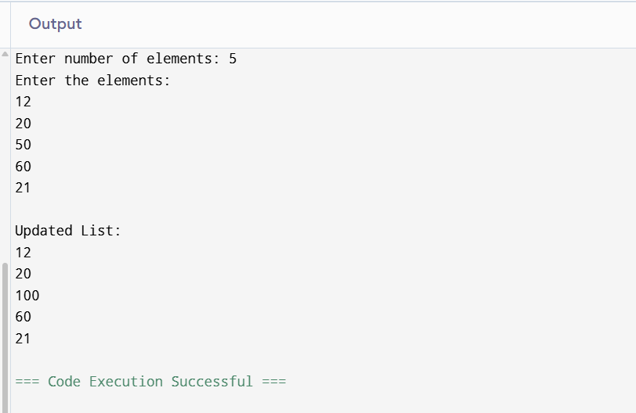

Conclusion
ListIterator is the most suitable traversal method because it allows sequential traversal and safe updating of list elements using the set() method during iteration.

Design a migration plan for replacing legacy raw collections with generic collections in a large codebase. Include compile-time strategy, testing, backward compatibility and risk management.

Aim
To design a migration plan for replacing legacy raw collections with generic collections in a large Java codebase while ensuring compile-time type safety, thorough testing, backward compatibility, and effective risk management.

Migration Plan
1. Compile-Time Strategy
- Identify all raw collections such as ArrayList, HashMap, LinkedList, etc.
- Replace them with generic collections.
  - Example:
ArrayList list = new ArrayList();
becomes
ArrayList<String> list = new ArrayList<>();
- Enable compiler warnings using:
javac -Xlint:unchecked
- Resolve all unchecked conversion and unchecked cast warnings.
- Use bounded generics (<? extends T>, <? super T>) where required.
- Perform migration module-by-module instead of changing the entire project at once.

2. Testing Strategy
- Run existing unit tests before migration.
- Modify test cases to use generic collections.
- Perform integration testing to ensure modules interact correctly.
- Execute regression testing to verify existing functionality remains unchanged.
- Conduct performance testing to compare execution time and memory usage before and after migration.

3. Backward Compatibility
- Maintain compatibility with legacy APIs using wrapper methods if required.
- Suppress unavoidable warnings using:
@SuppressWarnings("unchecked")
only after careful verification.
- Keep public method signatures unchanged wherever possible.
- Introduce adapters for components that still expect raw collections.

4. Risk Management
- Maintain version control (Git) with feature branches.
- Migrate one module at a time.
- Perform code reviews after each migration.
- Maintain backup branches for rollback.
- Monitor runtime logs for type-related exceptions.
- Train developers on Java Generics before migration.

Pseudocode
START

Identify all raw collections

FOR each module in the project
Find raw collections
Replace with generic collections
Compile with warnings enabled

IF compilation errors occur
Fix type mismatches
ENDIF

Run unit tests

IF tests fail
Fix errors
ENDIF

Run integration tests
Run regression tests

Commit changes to version control
END FOR

Deploy gradually

Monitor application

STOP

Java Program (Example Migration)
import java.util.*;

public class GenericMigration {

public static void main(String[] args) {

// Legacy Raw Collection
ArrayList rawList = new ArrayList();
rawList.add("Laptop");
rawList.add("Mouse");

// Generic Collection
ArrayList<String> genericList = new ArrayList<>();

for (Object obj : rawList) {
genericList.add((String) obj);
}

System.out.println("Generic Collection:");

for (String item : genericList) {
System.out.println(item);
}
}
}

Sample Input
Enter a string: Java
Enter a number: 100

Enter number of languages: 3
Enter the languages:
Java
Python
C++
Sample Output
Raw Collection:
Java
100

Generic Collection:
Java
Python
C++
Conclusion
Replacing raw collections with generic collections improves compile-time type safety, reduces runtime ClassCastExceptions, and makes code more readable and maintainable. A phased migration with compiler warnings, comprehensive testing, backward compatibility measures, and proper risk management ensures a safe and successful transition in a large codebase.

